Gestión de Bases de Datos

UD. 2. Modelo Entidad/Relación (E/R) y Modelo Relacional

Caso práctico 8.

1. Pasar la siguiente tabla a 3ª Forma Normal.

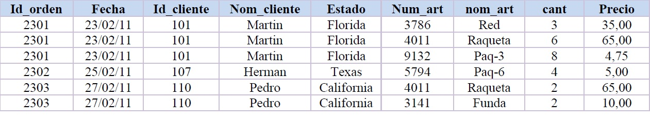

|  |  |  |
| --- | --- | --- |
| **Id_orden** | Fecha | Id_cliente |
| 2301 | 23/02/11 | 101 |
| 2301 | 23/02/11 | 101 |
| 2301 | 23/02/11 | 101 |
| 2302 | 25/02/11 | 107 |
| 2303 | 27/02/11 | 110 |
| 2303 | 27/02/11 | 110 |

|  |  |  |
| --- | --- | --- |
| **Id_Cliente** | Nom_Cliente | Estado |
| 101 | Martin | Florida |
| 101 | Martin | Florida |
| 101 | Martin | Florida |
| 107 | Herman | Texas |
| 110 | Pedro | California |
| 110 | Pedro | California |

|  |  |  |
| --- | --- | --- |
| **Id_Orden** | Num_art | Cantidad |
| 2301 | 3786 | 3 |
| 2301 | 4011 | 6 |
| 2301 | 9132 | 8 |
| 2302 | 5794 | 4 |
| 2303 | 4011 | 2 |
| 2303 | 3141 | 2 |

|  |  |  |
| --- | --- | --- |
| **Id_Cliente** | Nom_cliente | Estado |
| 101 | Martin | Florida |
| 101 | Martin | Florida |
| 101 | Martin | Florida |
| 107 | Herman | Texas |
| 110 | Pedro | California |
| 110 | Pedro | California |